Katie Kouril
Module 5.2 Assignment
January 25, 2026
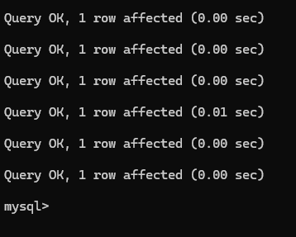
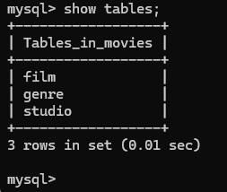

When trying to open the .env file – it pops up with this: 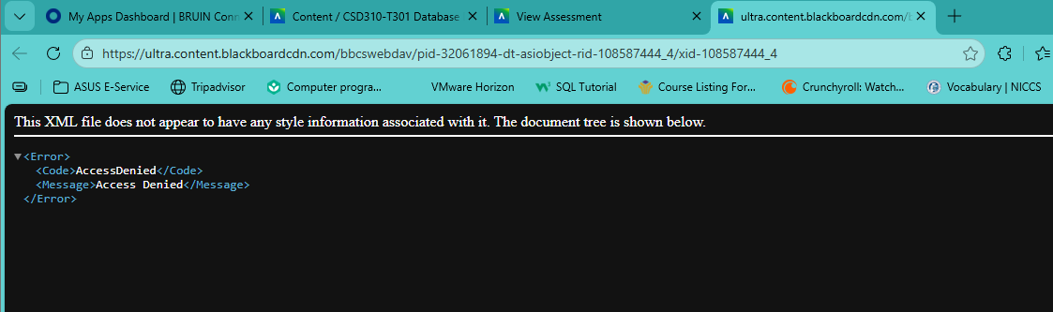
I tried from multiple browsers to try and download the file but it always popped up with the above picture.

